**CHAPTER 1**

**INTRODUCTION**



In the democratic nation of India, elections have always played a vital role in shaping the country's political landscape. As the largest democracy in the world, the process of conducting elections is of utmost importance to ensure fair representation and uphold the principles of democracy. However, the traditional voting system in India has faced several limitations, including inefficiencies, security concerns, and logistical challenges. This has prompted the need for a more advanced and robust voting system that can address these limitations and enhance the democratic process. In recent years, blockchain technology has emerged as a promising solution for various sectors, and its application in the realm of elections holds tremendous potential. This thesis aims to explore the development and implementation of a blockchain-based e-voting system in India, with a focus on overcoming the limitations of the traditional voting system and improving efficiency, transparency, and security.

* 1. **Background of India as a Republic**
     1. **Historical Perspective**

India, as a sovereign socialist secular democratic republic, has embraced democracy since its independence in 1947. The Constitution of India provides the framework for the functioning of the government and emphasizes the importance of free and fair elections as the cornerstone of democracy. Over the years, India has conducted multiple elections at various levels, including the Lok Sabha (Lower House of Parliament), State Legislative Assemblies, and local bodies, to ensure representation and public participation in decision-making processes.

* + 1. **Traditional Voting System in India**

The traditional voting system in India has been primarily paper-based, relying on the physical casting of votes using ballot papers. This process involves voters visiting designated polling stations, marking their preferences on ballot papers, and depositing them into sealed ballot boxes. While this system has served the country for decades, it faces several limitations that hinder its effectiveness and efficiency.

* + - 1. **Limitations of the Traditional Voting System**

One significant limitation of the traditional voting system is the logistical challenge associated with conducting elections in a geographically diverse and populous country like India. The process of setting up polling stations, distributing ballot papers, and ensuring a smooth voting experience for all citizens often poses challenges, especially in remote areas with limited infrastructure.

Additionally, the traditional voting system is susceptible to various malpractices, including booth capturing, bogus voting, and tampering with ballot boxes. Such incidents undermine the credibility of the electoral process and raise questions about the integrity of the results.

* + - 1. **Time and Cost Constraints**

Furthermore, the traditional voting system in India requires substantial time and resources for preparation, execution, and result tabulation. Counting votes and declaring results often take several days or weeks, leading to prolonged uncertainty and potential disputes. Moreover, the substantial financial resources required for organizing elections significantly burden the government.

* 1. **The Promise of Blockchain Technology**
     1. **Historical Perspective**

Blockchain technology is a revolutionary concept that has garnered significant attention across various industries. At its core, blockchain is a decentralized and transparent digital ledger that securely records and verifies transactions. It operates on a distributed network of computers, known as nodes, which work together to validate and store information. Unlike traditional centralized systems, blockchain offers unique advantages such as immutability, security, transparency, and efficiency. By eliminating the need for intermediaries and providing a tamper-proof record of transactions, blockchain technology has the potential to transform numerous sectors, including finance, supply chain management, healthcare, and even voting systems. Its ability to establish trust and enhance data integrity has made it an appealing solution for creating secure and accountable voting processes. By leveraging blockchain, voting systems can address challenges related to transparency, security, and audibility, ultimately revolutionizing how elections are conducted and ensuring a more inclusive and trustworthy democratic proc

* + 1. **Advantages of Blockchain in Voting Systems**

Blockchain technology offers several advantages when applied to a voting system:

**Transparency:** Blockchain provides a transparent and immutable ledger where all voting transactions are recorded. This transparency allows anyone to verify the integrity of the recorded votes, ensuring a fair and accountable system. It reduces the risk of fraud or manipulation as all transactions are visible to participants.

**Security:** Blockchain's decentralized nature and cryptographic algorithms enhance the security of the voting process. Each vote is securely recorded and encrypted, making it extremely difficult for unauthorized parties to tamper with or alter the results. The distributed nature of blockchain reduces the risk of a single point of failure or hacking.

**Integrity:** With blockchain, each vote can be linked to a unique digital identity, ensuring that only eligible voters can participate. This reduces the risk of fraudulent voting or double voting. The immutability of the blockchain prevents retroactive changes, ensuring the integrity of the voting process.

**Auditability:**  Blockchain technology enables a comprehensive and efficient audit trail. Every transaction, including the casting and counting of votes, is recorded and timestamped, providing a transparent and traceable history of the entire voting process. This makes it easier to conduct post-election audits and resolve any disputes.

**Accessibility:** Blockchain-based voting systems can potentially enhance accessibility by allowing remote voting and eliminating geographical barriers. Voters can securely cast their votes from anywhere, increasing participation rates and making the process more convenient for individuals who may have difficulty accessing traditional polling stations.

**Efficiency and Cost Reduction:** Implementing a blockchain-based voting system can streamline the entire process, reducing administrative overheads and costs associated with traditional voting methods. Smart contracts can automate various tasks, such as voter registration, ballot distribution, and result tabulation, saving time and resources.

**Trust and Confidence:** By leveraging blockchain technology, voting systems can increase public trust and confidence in the electoral process. The transparency, security, and integrity provided by blockchain contribute to a more trustworthy and auditable system, helping to alleviate concerns about fraud and manipulation.

* 1. **Development and Implementation of a Blockchain-Based E-Voting System in India**
     1. **Designing the Architecture**

The development of a blockchain-based e-voting system for India requires a well-designed architecture that accommodates the specific requirements of the country. This Project will delve into the key components of the system, including the blockchain network structure, voter identification mechanisms, the vote-casting process, and the result in tabulation procedures.

* + 1. **Overcoming Challenges and Ensuring Security**

Security is a critical aspect of any voting system, and a blockchain-based e-voting system is no exception. This chapter will explore the various security challenges associated with implementing such a system in India and propose robust mechanisms to address them. Topics of discussion will include authentication protocols, encryption techniques, voter privacy, and protection against cyber threats.

**CHAPTER 2**

**LITERATURE REVIEW**



1. The research paper titled "E-Voting System using Blockchain Technology: A Review" by M. M. Uddin et al. (2021) presents a comprehensive review of e-voting systems that utilize blockchain technology. The authors aim to provide an overview of the existing literature, approaches, and challenges related to the application of blockchain in e-voting.

The paper begins by discussing the limitations of traditional voting systems, such as security vulnerabilities, lack of transparency, and potential for manipulation. It highlights the potential benefits of integrating blockchain technology into e-voting systems, such as immutability, decentralization, and enhanced security. The authors review various e-voting systems based on blockchain, examining their key features, such as privacy, verifiability, and scalability. They discuss different aspects of these systems, including the use of cryptographic techniques for vote encryption and decryption, consensus algorithms for validation, and smart contracts for automation. The paper also addresses the challenges and open research areas in the field of blockchain-based e-voting systems. It discusses scalability, privacy, regulatory compliance, and user adoption concerns. The authors emphasize the need for further research and innovation to overcome these challenges and make blockchain-based e-voting systems more practical and accessible. Through their comprehensive review, the authors conclude that blockchain technology has the potential to revolutionize the e-voting landscape by providing enhanced security, transparency, and integrity. They highlight the importance of addressing the challenges and limitations to ensure the practicality and widespread adoption of blockchain-based e-voting systems. In summary, this research paper thoroughly reviews e-voting systems utilizing blockchain technology. It serves as a valuable resource for researchers and practitioners in the field, providing insights into the current state of the art, challenges, and future directions in the application of blockchain for e-voting systems.

1. The research paper titled "E-Voting System using Blockchain Technology: A Review" by M. M. Uddin et al. (2021) presents a comprehensive review of e-voting systems that utilize blockchain technology. The authors aim to provide an overview of the existing literature, approaches, and challenges related to the application of blockchain in e-voting.

In their system, a blockchain network is utilized to store and validate voting transactions. Each voter is assigned a unique digital identity, and their votes are recorded as transactions on the blockchain. The authors emphasize proposed the importance of maintaining voter privacy and propose the adoption of cryptographic techniques to achieve anonymity while ensuring verifiability. The paper highlights the advantages of using blockchain technology in e-voting systems, including immutability, transparency, and resistance to tampering. It discusses the use of consensus algorithms, such as Proof of Work or Proof of Stake, to ensure the integrity and validity of the voting process. The authors also address the issue of scalability in blockchain-based systems and propose potential solutions. The authors provide a detailed description of the design and implementation of their e-voting system, including the architecture, smart contracts, and user interfaces. They validate the system's effectiveness through testing and analysis, demonstrating its ability to improve security, transparency, and efficiency compared to traditional voting systems. In conclusion, this research paper contributes to the field of e-voting systems by presenting a design and implementation of an e-voting system based on blockchain technology. The proposed system offers enhanced security, transparency, and efficiency in the voting process, providing a foundation for further research and development in the area of blockchain-based e-voting systems.

1. The research paper titled "Decentralized E-Voting System Using Blockchain Technology" by A. A. Ahmed and S. A. Ibrahim (2020) introduces a decentralized e-voting system that leverages blockchain technology to enhance the security and transparency of the voting process. The authors identify the limitations of centralized e-voting systems, such as single points of failure and susceptibility to tampering, and propose a decentralized solution using blockchain.

In their proposed system, a blockchain network is employed to store and validate voting transactions. Each voter is assigned a unique digital identity, and their votes are recorded as transactions on the blockchain. The authors emphasize the importance of ensuring voter privacy and propose the use of cryptographic techniques to achieve anonymity while maintaining verifiability. The paper highlights the advantages of using blockchain technology in e-voting systems, such as immutability, transparency, and resistance to tampering. It discusses the use of consensus mechanisms, such as Proof of Work or Proof of Stake, to ensure the integrity and validity of the voting process. The authors also address the issue of scalability in blockchain-based systems and propose potential solutions. The authors provide a comprehensive evaluation of their proposed system through simulations and comparisons with traditional centralized e-voting systems. The results demonstrate that their decentralized e-voting system based on blockchain technology improves security, transparency, and reliability. In conclusion, this research paper contributes to the field of e-voting systems by presenting a decentralized approach that utilizes blockchain technology. By addressing the limitations of centralized systems, the proposed system offers increased security and transparency in the voting process. It serves as a foundation for further research and development in the application of blockchain technology for decentralized e-voting.

1. The research paper titled "Blockchain-Based E-Voting System: A Comprehensive Review" by M. A. Hossain et al. (2020) presents a comprehensive review of blockchain-based e-voting systems. The authors aim to provide an in-depth analysis of the existing literature, approaches, and challenges associated with utilizing blockchain technology in e-voting.

The paper starts by discussing the limitations of traditional e-voting systems, such as security vulnerabilities, lack of transparency, and potential for manipulation. It highlights the potential benefits of blockchain technology, such as immutability, decentralization, and transparency, which can address these limitations. The authors review various blockchain-based e-voting approaches proposed in the literature, analyzing their key features, such as voter anonymity, vote integrity, and verifiability. They discuss different aspects of these approaches, including the consensus mechanisms employed, data encryption techniques, and privacy-enhancing measures. The paper also provides insights into the challenges and open research issues in blockchain-based e-voting systems. It addresses concerns related to scalability, interoperability, voter authentication, and regulatory compliance. The authors emphasize the need for further research to overcome these challenges and develop practical solutions. Through their comprehensive review, the authors conclude that blockchain technology has the potential to enhance the security, transparency, and efficiency of e-voting systems. However, they note that the implementation of such systems requires careful consideration of various factors, including scalability, privacy, and legal implications. In summary, this research paper thoroughly reviews blockchain-based e-voting systems, highlighting their advantages, challenges, and future research directions. It serves as a valuable resource for researchers and practitioners interested in understanding and exploring the potential of blockchain technology in the context of e-voting.

1. The research paper titled "Towards a Blockchain-Based E-Voting System with Verifiability and Voter Privacy" by S. Upadhyay and M. Srivastava (2020) proposes an e-voting system that utilizes blockchain technology to achieve verifiability and voter privacy. The authors identify shortcomings in traditional e-voting systems, such as lack of transparency, susceptibility to manipulation, and compromise of voter privacy.

In their proposed system, a blockchain network is employed to create an immutable and transparent platform for conducting electronic voting. Each voter is assigned a unique digital identity, and their votes are encrypted and recorded as transactions on the blockchain. The authors emphasize the importance of maintaining voter privacy and propose the use of cryptographic techniques to achieve anonymity while enabling the verification of votes. To ensure verifiability, the authors introduce the concept of "cast-as-intended" and "count-as-cast" verifiability, where voters can confirm that their votes were recorded correctly and counted accurately. They also discuss the use of zero-knowledge proofs to allow the verification of votes without revealing the identity of the voter. The paper highlights the advantages of using blockchain in e-voting systems, including transparency, immutability, and resistance to tampering. It also addresses challenges related to scalability, voter authentication, and voter privacy. The authors provide a comprehensive evaluation of their proposed system, demonstrating its effectiveness through simulations and comparisons with traditional e-voting approaches. The results show that their blockchain-based e-voting system enhances verifiability, maintains voter privacy, and provides a robust framework for conducting secure and transparent elections. In conclusion, this research paper contributes to the field of e-voting systems by presenting a blockchain-based solution that ensures verifiability and voter privacy. By addressing the limitations of traditional systems, the proposed system offers a reliable and trustworthy platform for electronic voting.

1. The research paper titled "Enhancing E-Voting System Security using Blockchain Technology" by S. N. Khan et al. (2020) introduces a novel approach to improving the security of e-voting systems by leveraging blockchain technology. The authors identify security vulnerabilities in traditional e-voting systems, such as tampering, data manipulation, and lack of transparency.

In their proposed system, the authors employ a blockchain network to establish a secure and transparent platform for conducting electronic voting. Each voter is provided with a unique digital identity, and their votes are encrypted and recorded as transactions on the blockchain. The authors emphasize the importance of maintaining the anonymity of voters while ensuring the integrity and verifiability of the voting process. To enhance security, the authors implement cryptographic techniques, such as digital signatures and cryptographic hashing, to protect the integrity and authenticity of votes. They also discuss the use of distributed consensus algorithms to ensure agreement among network participants and prevent malicious activities. The paper highlights the advantages of using blockchain in e-voting systems, including immutability, transparency, and resistance to tampering. It also addresses potential challenges, such as scalability and the need for secure key management. The authors validate the effectiveness of their proposed system through simulations and comparisons with traditional e-voting systems. The results demonstrate that their blockchain-based approach enhances the security of e-voting systems, safeguards voter privacy, and ensures the integrity of the voting process. In conclusion, this research paper contributes to the field of e-voting systems by introducing a secure approach that utilizes blockchain technology. By addressing security vulnerabilities, ensuring privacy, and maintaining transparency, the proposed system offers a robust framework for conducting secure electronic voting.

1. The research paper titled "Secure E-Voting System Based on Blockchain Technology" by H. Ali, M. Raza, and R. Ahmed (2020) introduces a secure e-voting system that leverages blockchain technology. The authors identify the vulnerabilities and limitations of traditional e-voting systems, such as tampering, data integrity, and privacy concerns.

In their proposed system, a blockchain network is utilized to provide a decentralized and transparent platform for conducting secure electronic voting. Each voter is assigned a unique digital identity, and their votes are encrypted and recorded as transactions on the blockchain. The authors emphasize the importance of maintaining voter privacy and propose the adoption of cryptographic techniques to ensure anonymity while preserving the verifiability of votes. To enhance security, the authors integrate various mechanisms, including multi-factor authentication, cryptographic hashing, and digital signatures. These measures aim to prevent unauthorized access, ensure the integrity of voting data, and detect any attempts at tampering. The paper discusses the advantages of blockchain technology in e-voting systems, such as immutability, transparency, and distributed consensus. It also addresses challenges associated with scalability and regulatory compliance, suggesting potential solutions. The authors validate the effectiveness of their proposed system through simulations and comparative analyses with traditional e-voting approaches. They demonstrate that their blockchain-based e-voting system enhances security, maintains voter privacy, and provides a robust framework for conducting trustworthy elections. In conclusion, this research paper contributes to the field of e-voting systems by presenting a secure e-voting solution based on blockchain technology. It addresses the limitations of traditional systems and provides insights into how blockchain can enhance the security and integrity of electronic voting processes.

1. The research paper titled "Blockchain-Based E-Voting System with Improved Security and Usability" by S. H. Ahmed and A. Y. Barnawi (2020) proposes an e-voting system that utilizes blockchain technology to enhance security and usability. The authors address the existing challenges in traditional e-voting systems, such as privacy concerns, data integrity, and transparency.

In their proposed system, a blockchain network is employed to record and store voting transactions securely. Each voter is assigned a unique digital identity, and their votes are encrypted and stored as transactions on the blockchain. The authors emphasize the importance of voter privacy and propose the adoption of zero-knowledge proofs to ensure that votes remain anonymous while still being verifiable. To improve usability, the authors introduce a user-friendly interface for voters to easily participate in the voting process. They also integrate biometric authentication to enhance security and prevent unauthorized access. The paper discusses the benefits of using blockchain in e-voting systems, including resistance to tampering, transparency, and decentralized control. It also addresses potential challenges and limitations, such as scalability and the need for widespread adoption. The authors present a comprehensive evaluation of their proposed system through simulations and comparisons with traditional e-voting approaches. They demonstrate that their blockchain-based e-voting system improves security, maintains voter privacy, and ensures the integrity of the voting process. Overall, this research paper contributes to the field of e-voting systems by presenting a blockchain-based solution that offers enhanced security and usability, addressing key concerns in traditional voting systems.

**CHAPTER 3**

**PROBLEM STATEMENT**



The problem statement for e-voting using blockchain technology can be defined as follows**:**

Traditional voting systems face various challenges, including security vulnerabilities, lack of transparency, and potential for manipulation. These limitations raise concerns regarding the integrity and trustworthiness of the voting process. Additionally, centralized systems may be susceptible to single points of failure and unauthorized access, posing threats to voter privacy.

To address these issues, there is a need to develop a secure, transparent, and decentralized e-voting system using blockchain technology. This system should ensure the immutability and integrity of votes, provide verifiability and transparency throughout the process, protect the privacy of voters, and prevent tampering or manipulation of voting data. It should also address scalability concerns and ensure usability for both voters and election administrators.

The problem statement for e-voting using blockchain technology revolves around designing and implementing an efficient and reliable system that overcomes the limitations of traditional voting methods. The objective is to leverage the decentralized nature of blockchain to create a secure and transparent voting system that instills trust in the electoral process, protects voter privacy, and ensures the accuracy and integrity of election results.

**CHAPTER 4**

**PROJECT WORK ALONG WITH SPECIFICATION**

In order to develop and implement a robust and efficient system for the project, a careful selection of software and hardware components was made. These components play a crucial role in enabling the creation, testing, and deployment of smart contracts, as well as ensuring seamless interaction with the Ethereum blockchain. The chosen software tools provide a comprehensive development environment, while the hardware infrastructure supports the execution and performance of the system. By leveraging these carefully selected components, the project aims to achieve its objectives and deliver a user-friendly and decentralized solution. In the following sections, we will explore in detail the software and hardware components utilized in the project.

* 1. **Hardhat**

Hardhat is an advanced Ethereum development environment that simplifies the creation, testing, and deployment of smart contracts. With its user-friendly command-line interface (CLI), developers can efficiently compile, test, and deploy contracts. Hardhat ensures compatibility and adherence to Ethereum standards, offering seamless integration with popular testing frameworks. Its debugging capabilities enable swift identification and resolution of issues within smart contracts, ensuring reliability and robustness. Moreover, Hardhat provides flexibility in interacting with various Ethereum networks, allowing developers to deploy contracts on both local and public networks. With task automation features, developers can streamline their workflow, automating repetitive processes and enhancing productivity. By leveraging Hardhat's comprehensive toolset, developers can navigate the complexities of smart contract development with ease and deploy secure and efficient decentralized applications

Hardhat empowers developers with a comprehensive Ethereum development environment that optimizes the smart contract development lifecycle. Its user-friendly CLI simplifies contract compilation, testing, and deployment, enabling developers to focus on writing efficient and reliable code. By integrating popular testing frameworks, such as Mocha and Chai, Hardhat facilitates thorough contract testing, ensuring the functionality and security of smart contracts. Additionally, Hardhat offers robust debugging capabilities, allowing developers to step through code, inspect variables, and identify and resolve issues swiftly. With seamless integration with Ethereum networks, developers can deploy contracts on local or public networks, ensuring compatibility and scalability.

* 1. **Block-Chain**

Blockchain technology is a decentralized and distributed ledger system that has revolutionized various industries, including cryptocurrency. It is built on a chain of blocks containing transaction records, linked using cryptographic hashes, creating an immutable and transparent ledger. The decentralized nature of blockchain ensures high security, as no single entity has control over the system. Transactions are encrypted and linked to previous ones, making tampering difficult. Consensus mechanisms like Proof of Work or Proof of Stake validate and agree upon new block inclusion. Blockchain technology offers numerous benefits. Transparency is a key feature, as all participants can view and verify transactions. This eliminates the need for intermediaries and fosters trust.



4.2.1 Block-Chain Representation

Transactions recorded on the blockchain are nearly impossible to alter or delete, ensuring data immutability. This is particularly valuable for supply chain management and fraud prevention. Efficiency is another advantage, as blockchain eliminates intermediaries and streamlines processes, reducing costs. Transactions can occur directly between parties, enhancing speed, especially in cross-border payments. Smart contracts automate processes based on predefined rules, further improving efficiency and reducing errors. Decentralization is a fundamental characteristic of blockchain, providing resilience and fault tolerance. No central authority exists, ensuring the system remains operational even if some nodes fail. Users have greater control over their data and assets, eliminating dependence on intermediaries.

* 1. **MetaMask**

Metamask is a browser extension and cryptocurrency wallet that provides users with a secure and convenient way to interact with decentralized applications (DApps) on the Ethereum blockchain. It serves as a bridge between web browsers and the Ethereum network, enabling users to seamlessly manage their Ethereum-based assets and engage with various blockchain-based applications. With Metamask, users can securely store and control their Ethereum and ERC-20 tokens within a digital wallet. It generates and manages cryptographic key pairs, ensuring the safe storage of users' private keys and providing full ownership and control over their funds. The wallet also offers a 12-word seed phrase that can be used to recover the wallet and funds if needed.

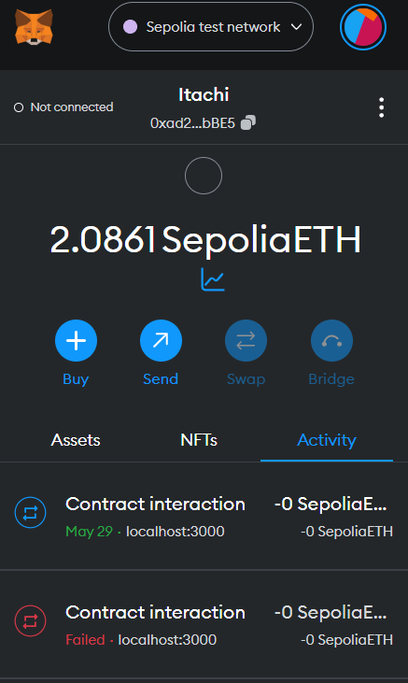

4.3.1 MetaMask Account page

One of the primary advantages of Metamask is its integration as a browser extension. Once installed, it injects a user interface into web pages, allowing users to interact with Ethereum-powered DApps directly from their browser. This eliminates the need for users to manually connect their wallets or input sensitive information on different websites, streamlining the user experience and enhancing security. Metamask simplifies the process of interacting with DApps by providing a user-friendly interface. Users can send and receive Ethereum and tokens, view their transaction histories, and manage multiple accounts within the wallet. It also allows users to customize transaction gas fees, providing flexibility and control over transaction costs and speed

* 1. **Remix IDE**

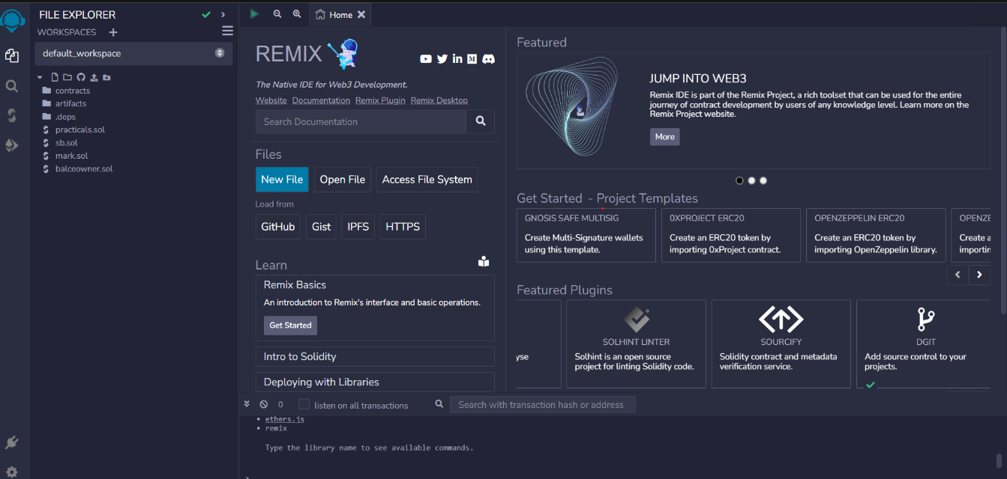Remix IDE is a popular integrated development environment (IDE) specifically designed for Ethereum smart contract development. It provides developers with a range of powerful tools and features to streamline the process of creating, testing, and deploying smart contracts on the Ethereum blockchain. One of the key advantages of Remix IDE is its browser-based interface, which allows developers to access and work on their projects directly from their web browser. This eliminates the need for complex software installations and provides a convenient and accessible development environment. Remix IDE offers a code editor with syntax highlighting and autocompletion specifically tailored for Solidity, the programming language used for writing smart contracts on Ethereum. This helps developers write clean and error-free code and improves overall coding efficiency. The IDE also includes a built-in Solidity compiler, enabling developers to compile their smart contracts within the environment.

4.4.1 Remix IDE Home Page

This allows for instant feedback on potential compilation errors or warnings, helping catch and address issues early in the development process. Remix IDE features a debugger that allows developers to step through their smart contract code, set breakpoints, and inspect variables. This invaluable tool facilitates the debugging process and helps identify and resolve any issues or bugs in the contract logic.

Additionally, Remix IDE provides a testing framework that enables developers to write and execute unit tests for their smart contracts. This ensures the integrity and correctness of the contract's functionality before deploying it to the Ethereum network. Furthermore, Remix IDE offers a user-friendly interface for deploying smart contracts to different Ethereum networks, such as the main-net or various testnet. It simplifies the deployment process and provides developers with an intuitive way to configure deployment parameters and interact with deployed contracts.

* 1. **Solidity**

Solidity is a high-level programming language specifically designed for writing smart contracts on the Ethereum blockchain. It is a statically-typed language that supports object-oriented programming principles and is inspired by languages such as C++, JavaScript, and Python. One of the primary purposes of Solidity is to define the rules and behavior of smart contracts. It allows developers to specify the conditions and actions that will be executed when certain events occur on the blockchain. Solidity supports the creation of complex contract logic, including conditional statements, loops, and functions. Solidity provides various data types, including integers, booleans, strings, arrays, and structs, which enable developers to store and manipulate data within smart contracts. It also supports custom data structures and user-defined types, allowing for the creation of complex data models.

Security is of utmost importance in smart contract development, and Solidity incorporates various features to address potential vulnerabilities. It includes mechanisms for access control, input validation, and exception handling, which help developers write more secure and robust smart contracts. One notable feature of Solidity is its support for contract inheritance, allowing developers to create modular and reusable code. Contracts can inherit properties and functions from other contracts, facilitating code organization and reducing redundancy.

Solidity is a powerful language that enables developers to define and implement the logic of smart contracts on the Ethereum blockchain. Its rich feature set, security considerations, and compatibility with various development tools make it a popular choice for Ethereum-based decentralized application development.

* 1. **Smart Contract**

A smart contract is a self-executing contract with the terms of the agreement directly written into code. It operates on the blockchain, ensuring transparency, security, and automation of transactions without the need for intermediaries. Smart contracts are built using programming languages like Solidity and are typically deployed on blockchain platforms such as Ethereum. They function based on predefined rules and conditions, automatically executing actions when specific conditions are met. This eliminates the need for manual enforcement and reduces the potential for human error or manipulation. One of the key benefits of smart contracts is their ability to facilitate trust and transparency. Since the contract terms are encoded in the blockchain, they cannot be altered or tampered with, providing a

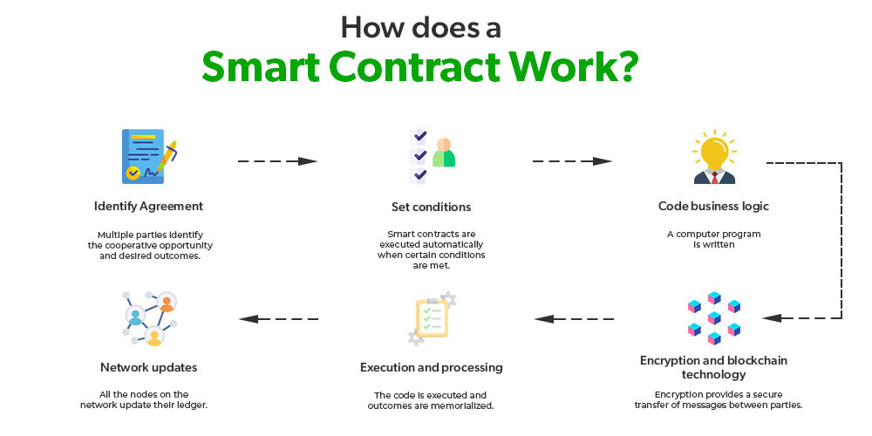

4.6.1 Smart Contract Work-Flow

reliable and immutable record of transactions. This transparency builds trust among the parties involved and reduces the need for intermediaries.

Automation is another significant advantage of smart contracts. Once deployed, they automatically execute predefined actions without the need for human intervention. This streamlines processes, reduces administrative overhead, and eliminates the possibility of delays or disputes arising from manual execution. Smart contracts also enhance security by utilizing the inherent security features of blockchain technology. The decentralized nature of blockchain ensures that no single entity has control over the contract, making it resistant to hacking or manipulation. Additionally, smart contracts use cryptographic techniques to secure and verify transactions, further enhancing their security. Moreover, smart contracts have a wide range of applications. They can be used for various purposes, such as financial transactions, supply chain management, voting systems, insurance claims, and decentralized applications (DApps). Their versatility and flexibility make them a powerful tool for automating and executing complex agreements and processes.

Smart contracts are self-executing contracts with predefined terms and conditions written into code. They operate on blockchain platforms, providing transparency, security, and automation of transactions. Smart contracts enhance trust, streamline processes, and have diverse applications across industries.

* 1. **React JS**

React.js is a popular JavaScript library used for building user interfaces. It provides a component-based approach, allowing developers to create reusable UI elements and efficiently manage the application state. React.js utilizes a virtual DOM (



4.7.1 REACT JS Representation

React.js also introduces a concept called "unidirectional data flow," where data flows in a single direction, making it easier to understand and debug the application. This data flow pattern improves predictability and helps maintain a consistent state throughout the application. Furthermore, React.js has a thriving ecosystem with a vast collection of third-party libraries and tools that extend its capabilities. These libraries provide additional functionality, such as routing, state management, and form validation, allowing developers to build complex applications efficiently.

* 1. **Sepolia**

Sepolia is one of Ethereum’s most prominent proof-of-stake (PoS) testnets and was initially introduced in October 2021. Further, Sepolia is one of two primary testnets – along with Goerli – that have not been deprecated. This means that Sepolia is currently maintained by client developers ensuring that it is a safe and accurate test environment.

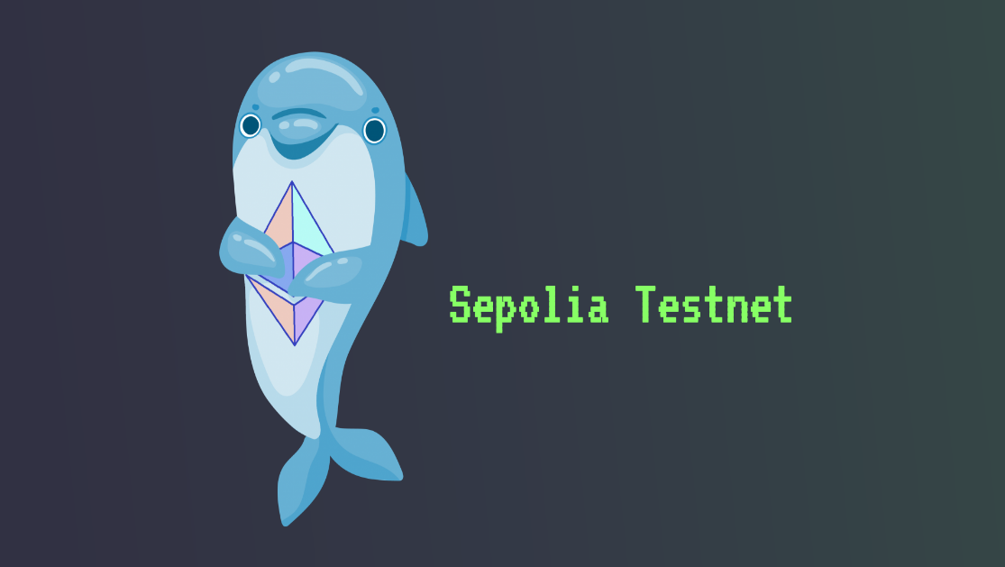

4.8.1 Sepolia Test Net Logo

At launch in 2021, Sepolia originally implemented a proof-of-work (PoW) consensus mechanism. However, with the advent of The Merge, Sepolia joined with the PoS Sepolia Beacon Chain and – much like the Ethereum mainnet – now applies a PoS consensus mechanism. Since The Merge, Sepolia now mimics the Ethereum mainnet, making it suitable for testing smart contracts and apps in an accurate environment. However, why do you need a testnet such as Sepolia in the first place? If you did not already know, gas is required to pay for on-chain transactions. Consequently, it can become costly to develop dapps and other blockchain projects directly on a mainnet like Ethereum. This is where testnets like Sepolia enter the picture to provide a more economically friendly and seamless developer experience. Sepolia is almost an identical copy of Ethereum, which Web3 developers can use to test-run their Web3 projects. As such, developers can design, create, test, and track their project’s public performance before committing to the Ethereum mainnet.

* 1. **Project Working**

The project involves the development of a comprehensive voting system comprising six key components. It aims to provide a user-friendly and secure platform for conducting elections. The system includes features such as a home page with instructions and video tutorials to guide users through the voting process. Administrators can add voters by verifying their Aadhaar card details against a MongoDB database. Candidates can be added, and the election parameters, including start and end times, can be set. The voting process involves user verification, OTP authentication, and vote recording. After the election concludes, administrators can access the result viewing section to analyze and report the outcomes. This project ensures efficient and transparent elections while maintaining data security and accuracy.

The project comprises six key components that collectively form a comprehensive voting system:

**Home Page**

The home page is the initial interface of the voting system, designed to provide users with a clear and intuitive starting point. It serves as a hub for accessing various sections and functionalities within the system. The primary purpose of the home page is to guide users through the voting process effectively. On the home page, users will find an instruction section that provides comprehensive guidance on how to use the voting system. This section offers step-by-step instructions, ensuring users understand the process and are able to navigate through the system with ease.

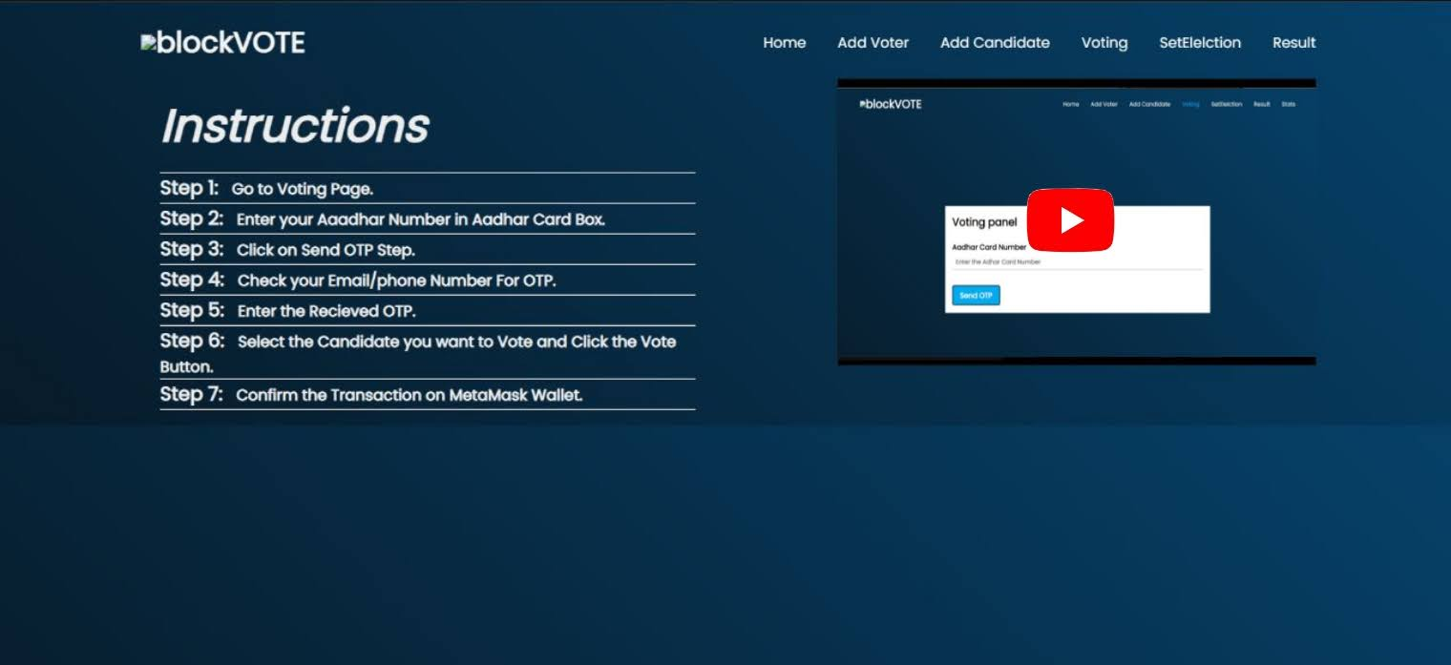

4.9.1 Home page of Project

In addition to textual instructions, the home page includes video tutorials. These tutorials visually demonstrate the different stages of the voting process, offering a more engaging and interactive experience for users. The videos walk users through each step, illustrating how to cast their votes and utilize the system's features effectively.

By incorporating both textual instructions and video tutorials, the home page aims to cater to users with different learning preferences and ensure that they have all the necessary information to participate in the voting process confidently.

**Add Voter**

The "Add Voter" section is a crucial component of the voting system that enables administrators to add eligible voters to the system. This section acts as a gateway to maintain an accurate and up-to-date voter registry.

Administrators have the authority to input the necessary details of voters who belong to a specific constituency. These details typically include information such as the voter's Aadhaar card number, name, address, and other relevant identification data. This data is securely stored in a MongoDB database, ensuring the confidentiality and integrity of voter information.

4.9.2 Add Voter Page of Project

To ensure the authenticity of the added voters, the system performs a verification process. This involves cross-referencing the provided Aadhaar card details with the existing voter database. If the system finds a match, indicating that the voter is already registered, the addition process is halted to prevent duplicate entries. However, if the Aadhaar card details are not found in the database, the voter is successfully added and becomes eligible to participate in the voting process.

By employing the "Add Voter" section, administrators can effectively manage and update the voter registry. This feature helps maintain the accuracy and validity of the system by ensuring that only eligible voters are added and authorized to exercise their voting rights

**Add Candidate**

The "Add Candidate" section is a key component of the voting system that empowers administrators to add candidates to the election process. This section serves as a platform for managing and organizing the candidate pool effectively.

Administrators have the authority to input comprehensive candidate information, including their name, party affiliation, and any other relevant details. This information ensures transparency and enables voters to make informed decisions during the voting process. In the "Add Candidate" section, administrators initiate the transaction to officially include the candidate in the election. This process involves recording the candidate's details and securely storing them in the system. By doing so, the candidate becomes a legitimate participant in the election, allowing voters to choose from a diverse range of candidates.

The "Add Candidate" section facilitates the seamless integration of candidates into the voting system, streamlining the overall election management process. It ensures that administrators have the necessary tools to efficiently add and manage candidate information, promoting fairness and transparency throughout the election.

Overall, the "Add Candidate" section provides administrators with the means to add candidates, record their details, and enable their participation in the election. This component plays a crucial role in establishing a comprehensive candidate pool and ensuring that voters have a wide range of choices when casting their votes.

 4.9.3 Candidate Register Page

**Set Election**

The "Set Election" feature is an essential component of the voting system that allows administrators to establish the start and end times of the election. This functionality ensures that the voting process remains within a predefined timeframe, providing structure and control to the overall election management. Using the "Set Election" feature, administrators can define the specific start and end dates and times for the election period. These timestamps are recorded in the epoch format, which represents time as the number of seconds that have elapsed since a specific reference point called the "epoch." This format simplifies the handling and comparison of time data, allowing for precise and consistent calculations.

Epoch time is commonly used in computer systems and databases as it provides a standardized method of representing time that is independent of time zones or local conventions. It simplifies operations such as determining the duration of the election, comparing timestamps, and managing time-based events.

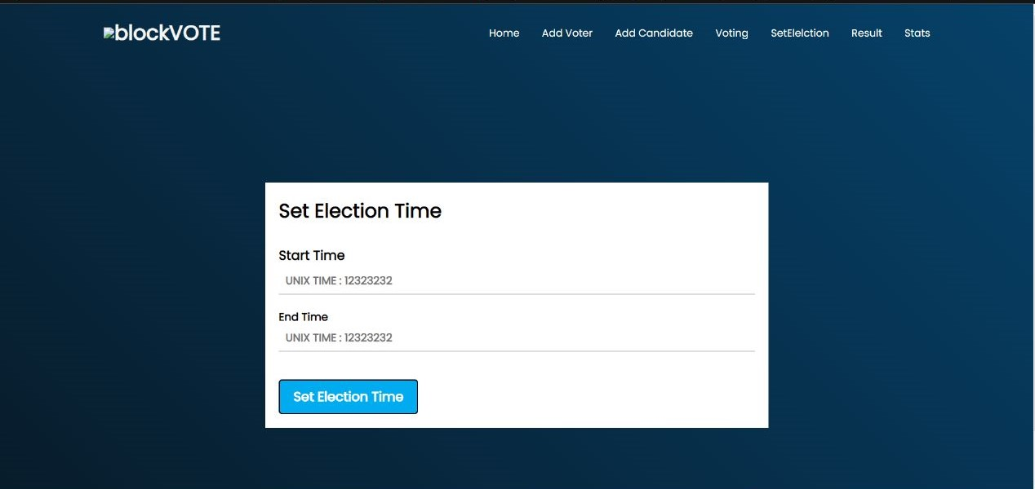By utilizing epoch time, the voting system ensures accurate tracking and synchronization of the election period across different components and functionalities. It provides a reliable and standardized method for determining when the voting process should commence and conclude.

4.9.4 Set Election Time Panel

Overall, the "Set Election" feature enables administrators to establish the start and end times of the election using the epoch format. This ensures consistency, precision, and synchronization throughout the voting system, facilitating effective management of the election period.

**Voting**

The voting process in this project encompasses several stages, ensuring a secure, transparent, and user-friendly experience for all participants. Starting with the voter verification and registration phase, the system verifies the eligibility of voters by validating their Aadhaar card details against a registered database.

Once a voter's eligibility is confirmed, they proceed to the voting section, where they are required to enter their unique Aadhaar card number. Upon entering the Aadhaar card number, the system prompts the user to click the "Send OTP" button to initiate the One-Time Password (OTP) authentication process. The voter receives the OTP on their registered email address, adding an additional layer of security to the voting process. After successfully entering the OTP, the voter gains access to the candidate selection interface. Here, they can view the profiles of the candidates running in the election, including their names, parties, and other relevant information. The voter can make their candidate selection by clicking on the corresponding option.

When a voter casts their vote, the system accurately records and adds it to the respective candidate's vote count. This ensures the integrity and accuracy of the voting process. The system also includes checks to prevent multiple votes from the same voter and ensures that voters can only vote once for a particular election.

4.9.5 Opening Voting Page

Throughout the voting process, the system maintains a detailed log of each voter's activities, ensuring transparency and accountability. This log captures information such as the time of voting, the candidates chosen by the voter, and any relevant user interactions within the system.

Upon the completion of the designated end time for the election, the system automatically disables the voting functionality. At this point, administrators gain access to the result viewing section. This section provides a comprehensive overview of the election outcomes, presenting the vote counts for each candidate and displaying the results in a clear and concise format.

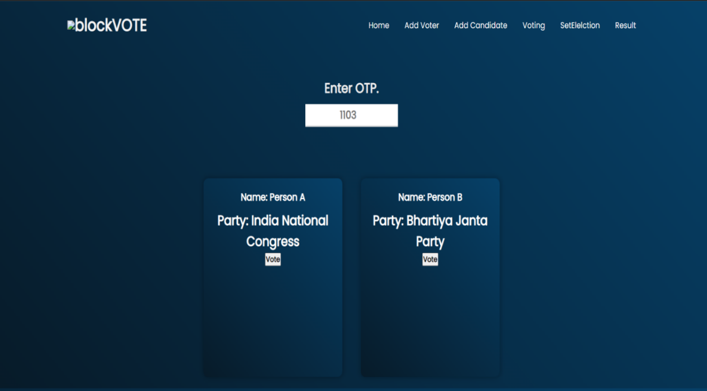Administrators can generate reports and analyze the election results, gaining insights into voter preferences, candidate performance, and other relevant metrics. This enables administrators to evaluate the election process and make informed decisions based on the outcomes.

4.9.6 Candidate Vote Page

In summary, the voting process in this project incorporates robust security measures, including voter verification through Aadhaar card authentication and OTP validation. The system ensures transparency and accuracy by accurately recording and tallying votes. By providing administrators with comprehensive result viewing and analysis capabilities, the project offers a reliable and efficient platform for conducting elections.

**Result**

The result page in the voting system serves as a comprehensive display of the election outcomes. It provides administrators with a concise and visually appealing overview of the results, enabling them to analyze and interpret the data effectively.

On the result page, administrators can view the vote counts for each candidate who participated in the election. The vote counts are presented in a clear and organized manner, allowing for easy comparison and identification of the candidate with the highest number of votes

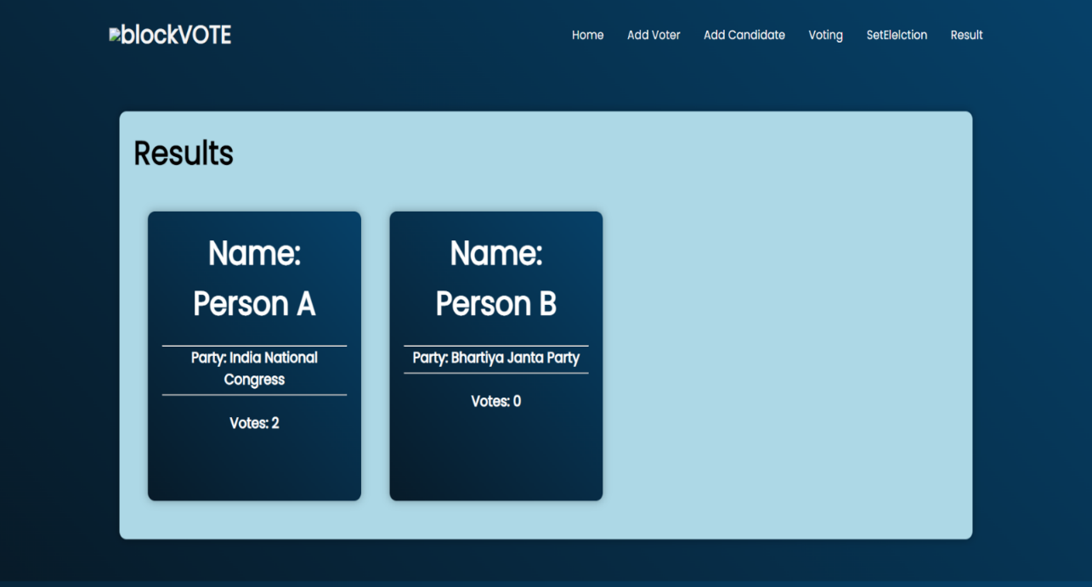The result page may include graphical representations, such as charts or graphs, to visually represent the vote distribution. These visual aids help administrators quickly grasp the overall voting trends and patterns, providing valuable insights into the preferences of the electorate.

4.9.7 Result page of the Project

In addition to candidate-specific results, the result page may also display aggregate statistics, such as the total number of votes cast, voter turnout percentage, and any other relevant metrics. This information gives administrators a holistic understanding of the election's overall performance.

The result page plays a crucial role in promoting transparency and accountability in the voting process. It ensures that administrators have access to accurate and up-to-date information regarding the election outcomes. By providing a comprehensive snapshot of the results, the page enables administrators to evaluate the success of the election and make data-driven decisions based on the analysis.

Overall, the result page in the voting system serves as a vital tool for administrators to access and interpret election outcomes. It presents the vote counts, graphical representations, and aggregate statistics, enabling administrators to assess the overall performance and draw meaningful conclusions from the data.

* 1. **Step-Wise Guide to Voting**

To cast their vote, a voter proceeds through the following comprehensive steps:

1. The voter initiates the voting process by accessing the dedicated voting page on the BlockVote website.
2. In order to verify their eligibility, the voter is prompted to provide their unique Aadhar number.
3. The system generates an OTP, which is then transmitted to the mobile number registered with the provided Aadhar number. This multi-factor authentication approach enhances the security of the voting process.
4. Upon receiving the OTP, the voter proceeds to enter it into the system for verification purposes.
5. Once the OTP is successfully validated, the voter gains access to the full list of candidates and can exercise their right to vote by selecting their preferred candidate.
6. The voting system accurately records the voter's choice, and the vote is attributed to the respective candidate, contributing to their overall tally.

The implementation of BlockVote ensures the utmost security, transparency, and authenticity of the voting system. By harnessing the potential of blockchain technology, the project guarantees an immutable record of votes, thereby eliminating the possibility of fraudulent activities or tampering. The utilization of React, a powerful JavaScript library, enhances the user experience by providing an intuitive and responsive interface. Additionally, rigorous security measures are put in place to protect sensitive data and prevent unauthorized access.

The BlockVote project represents a significant milestone in the realm of E-voting. By combining the benefits of blockchain technology with a well-designed React website, the project delivers a secure, efficient, and transparent platform for conducting elections. With its robust voting, candidate management, and voter registration components, BlockVote represents a paradigm shift in electoral systems, ensuring the integrity and legitimacy of democratic processe

**CHAPTER 5**

**LIMITATIONS OF THE PROJECT**



**5.1 Voter Trust and Acceptance**: Adopting a new electronic voting system may face initial skepticism or resistance from voters who are accustomed to traditional voting methods. Building trust and ensuring widespread acceptance of the electronic voting system among the electorate might require effective communication and awareness campaigns.

**5.2 User Accessibility:** The project assumes that all voters and administrators have access to the necessary technology and internet connectivity to interact with the system. However, limitations in digital literacy or lack of access to internet services may hinder certain individuals' participation and engagement with the voting process.

**5. 3 Time Consumption:** Another limitation of the project is the potential time-consuming nature of transactions due to its reliance on blockchain technology. As a blockchain-based system, every action, such as voter registration, candidate addition, and vote casting, requires a transaction to be recorded on the blockchain network

**CHAPTER 6**

**ADVANTAGES OF THE PROJECT**



**6.1 Transparency:** By leveraging blockchain technology, the project enhances transparency in the voting process. Each transaction and record is stored on a decentralized and immutable ledger, providing a transparent and auditable trail of all activities. This helps to build trust among voters and stakeholders, ensuring the integrity of the election.

**6.2 Elimination of Duplicate Voting:** Through the use of unique Aadhaar card verification, the project mitigates the risk of duplicate voting. Each voter is registered and verified based on their unique identification, ensuring that they can only cast a single vote. This helps to maintain the fairness and integrity of the election process.

**6.3 Cost-effectiveness:** The adoption of a blockchain-based voting system can potentially reduce costs associated with traditional voting methods. It eliminates the need for physical ballot papers, printing, and manual vote-counting processes, thereby saving resources and minimizing administrative expenses.

**6.4 Security:** The implementation of security measures such as Aadhaar card verification and OTP authentication helps to enhance the security of the voting system. The use of blockchain technology provides inherent security features like data immutability and cryptographic algorithms, making it difficult for unauthorized parties to manipulate or tamper with voting dat

**CHAPTER 7**

**APPLICATION & FUTURE SCOPE**



**5.1 Future Scope of the Project**

The successful implementation and testing of the E-voting website using React and blockchain technology pave the way for several potential future developments and applications in the field of e-voting. The following are some key areas for future exploration and enhancement:

1. **Scalability and Performance:** Further research and development are required to address the scalability challenges associated with blockchain-based e-voting systems. Solutions such as sharding or layer-two protocols can be explored to increase the transaction throughput and reduce the processing time. Optimizing the performance of the website and blockchain network will ensure its feasibility for large-scale elections with millions of voters.

**2. Privacy and Confidentiality**: Enhancing privacy features within the e-voting system is crucial. Future work can focus on integrating privacy-enhancing technologies, such as zero-knowledge proofs or homomorphic encryption, to ensure voter anonymity and protect sensitive voter information. Striking the right balance between transparency and privacy will be a key area of research.

**3. Integration with Digital Identity Solutions:** Integrating the e-voting system with robust digital identity solutions can further enhance the security and credibility of the voting process. Exploring partnerships with existing identity providers or leveraging decentralized identity frameworks can enable secure and verifiable voter authentication, minimizing the risk of identity fraud.

**4. Blockchain Interoperability:** Investigating interoperability solutions to facilitate communication and data exchange between different blockchain networks can be explored. This would allow for seamless integration with other blockchain-based applications and systems, promoting cross-platform compatibility and enhancing the overall efficiency of the e-voting ecosystem.

**5. Regulatory Framework and Legal Considerations:** Establishing a comprehensive regulatory framework and legal framework specific to blockchain-based e-voting is necessary. Collaborating with policymakers, electoral commissions, and legal experts to address legal challenges, define standards, and ensure compliance will be essential for the widespread adoption and acceptance of blockchain-based e-voting systems.

**5.2 Applications of the Project**

The application of the developed E-voting website using React and blockchain technology extends beyond national elections. The system can be adapted and deployed for various other voting scenarios, such as:

1. **Corporate Governance:** The technology can be applied to corporate governance processes, enabling secure and transparent shareholder voting for major decisions and board member elections.
2. **Community Decision Making:** Blockchain-based e-voting systems can be implemented at the local level for community decision-making processes, such as town hall meetings or neighborhood association elections.
3. **Student Body Elections:** Educational institutions can leverage the system to conduct student body elections, ensuring fairness, transparency, and accuracy in the voting process.
4. **Trade Union Voting:** Blockchain-based e-voting can facilitate secure and verifiable voting in trade unions, ensuring fair representation and decision-making processes.

**5. Referendums and Polling:** Governments can utilize the system to conduct referendums and public opinion polls, providing a secure and tamper-proof platform for citizen engagement and decision-making.

It is important to note that the successful adoption and implementation of blockchain-based e-voting systems require collaboration among multiple stakeholders, including governments, electoral commissions, technology providers, and the public. Ongoing research, pilot projects, and iterative improvements will be necessary to address challenges, gain trust, and ensure the long-term sustainability and effectiveness of such systems.

By exploring these future directions and applications, the field of e-voting can continue to evolve, embracing technological advancements and contributing to more inclusive, transparent, and trustworthy democratic processes.

**CHAPTER 8**

**CONCLUSION**



The successful implementation of an E-voting website using React and blockchain technology can revolutionize India's voting system. This approach addresses challenges faced by the traditional system and offers inherent features that can significantly impact the electoral process. Blockchain-based e-voting ensures tamper-proof and verifiable voting records, enhancing trust in the integrity of election results. The transparency of blockchain technology increases accountability and scrutiny, making the entire voting process auditable and reducing doubts and suspicions.

Decentralization eliminates reliance on a central authority, making the system resilient to corruption and manipulation. This promotes a fair and impartial system that upholds democratic values.

The E-voting website improves accessibility and convenience for voters. With a secure digital platform, individuals can vote remotely, removing barriers for physically disabled, elderly, and remote voters. This promotes inclusivity and increases voter turnout.

However, careful consideration of legal and regulatory frameworks is necessary, along with ensuring data privacy and protection. Mechanisms for robust voter authentication and identity verification are crucial to maintain the system's integrity and prevent fraud.

In conclusion, integrating React and blockchain technology into an E-voting website has the potential to bring transformative change to India's voting system. By addressing challenges related to transparency, security, accessibility, and accountability, blockchain-based e-voting can contribute to a trustworthy and inclusive democratic process. Comprehensive evaluations, pilot projects, and collaboration with stakeholders are essential to assess the feasibility and potential impact within the Indian electoral landscape.

**REFERENCES**

|  |  |
| --- | --- |
| [1] | B.L.Shivakumar, Lt. Dr. S.Santhosh Baboo, “Detecting Copy-Move Forgery in Digital Images: A Survey and Analysis of Current Methods,” Global Journal of Computer Science and Technology, Vol. 10 Issue 7, September 2010, pp. 61-65. |
| [2] | Somayeh Sadeghi, Hamid A. Jalab and Sajjad Dadkhah, “Efficient Copy-Move Forgery Detection for Digital Images,” World Academy of Science, Engineering, and Technology, 2012, pp. 755-758. |
| [3] | Vincent Christlein, Christian Riess, Johannes Jordan, Corinna Riess, Elli Angelopoulou, “An Evaluation of Popular Copy-Move Forgery Detection Approaches,” IEEE Transactions On Information Forensics And Security,2012, pp. 1-26. |
| [4] | Fridrich, D. Soukal, and J. Lukas, “Detection of copy-move forgery in digital images,” in Proceedings of Digital Forensic Research Workshop, Aug. 2003. |
| [5] | B. Mahdian and S. Saic, “Detection of Copy-Move Forgery using a Method Based on Blur Moment invariants,” Forensic Science International, vol. 171, no. 2, Dec. 2007, pp. 180–189. |
| [6] | B.L. Shivakumar and S. Baboo, “Detection of Region Duplication Forgery in Digital Images Using SURF,” International Journal of Computer Science Issues, vol. 8, no. 4, 2011, pp. 199–205. |
| [7] | David G. Lowe, “Distinctive Image Features from Scale-Invariant Keypoints,” International Journal of Computer Vision 60(2), 2004, pp.91–110. |
| [8] | I. Amerini, L. Ballan, R. Caldelli, A. D. Bimbo, and G. Serra, “A SIFT-based Forensic Method for Copy-Move Attack Detection and Transformation Recovery,” IEEE Transactions on Information Forensics and Security, vol. 6, no. 3, Sep. 2011, pp. 1099–1110. |